Grade 7 Accelerated · Unit 3 · Lesson 2  Quotient Laws of Exponents  Question Bank - Additional 3.02 ANSWER KEY | Name  Date  Period

Show your work. Circle your final answer.
For questions 1 through 3, show the quotient of powers law, then evaluate.
1. 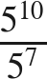


2. 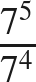


3. 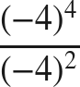
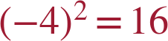
Two negative factors: positive.

4. When raising a fraction to a power, the numerator and the denominator are each raised to the ______ power.
same

For questions 5 and 6, apply the power of a quotient law. Do not simplify the fraction.
5. 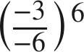
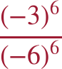
Both parts positive after an even power; the value is (1/2)⁶ = 1/64.

6. 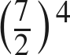

= 2401/16.

The zero exponent.
7. Fill in the missing value in the pattern: 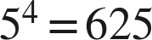, 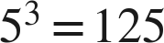, 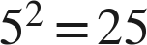, 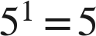, 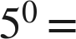 ____
1

8. Evaluate 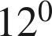 and 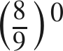.
1 and 1

For questions 9 and 10, rewrite the expression using a law of exponents, name the law, then evaluate.
9. 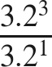
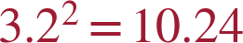 — quotient of powers

10. 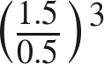
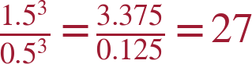 — power of a quotient (or 3³ = 27)

Working backwards.
11. Find the value of that makes each statement true.
a. 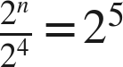
n = 9
b. 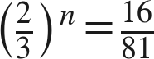
n = 4
c. 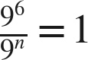
n = 6

12. Which expression is equivalent to 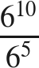 ?
○ A. 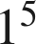
○ B. 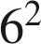
○ C. 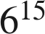
● D. 
D

13. Select ALL of the expressions whose value is 1.
☒ A. 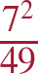
☐ B. 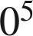
☐ C. 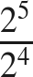
☒ D. 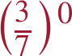
☒ E. 
☒ F. 
A, D, E and F
A: 7² = 49, so 49/49 = 1.

